# Analysis of the Original CLT/FLE Study

# 1. Exploration of the Original Dataset

This first section aims to explore the key variables upon which we can base our replication study of Díaz-Lago and Matute (2019) . Their open dataset includes data from two experiments that examine the relationship between the Causality Bias and the Foreign Language Effect (FLE). In this section, we will also investigate critical differences between the two experiments in order to determine which one more closely aligns with the study we intend to develop.

## 1.1 Importing Data

As the first step, we will import the dataset and convert the variables into appropriate formats for analysis.

# Importing the dataset  
datacomplete <- read.csv2("datasetFLE.csv")  
  
# Converting to factor  
datacomplete$experiment <- as.factor(datacomplete$experiment)  
datacomplete$gender <- as.factor(datacomplete$gender)  
datacomplete$nativeLanguage <- as.factor(datacomplete$nativeLanguage)  
datacomplete$experimentLanguage <- as.factor(datacomplete$experimentLanguage)  
datacomplete$contingency <- as.factor(datacomplete$contingency)

The variables are as follows:

* Experiment: nominal variable with two levels (first experiment or second experiment);
* Age: numerical variable (age expressed in years);
* Gender: nominal variable with two levels (M or F);
* Native Language (NL): nominal variable with two levels (English or Spanish);
* Language used in the experiment: nominal variable with two levels (NL or FL);
* Contingency: nominal variable with two levels (causal illusion or true causality);
* Self-assessed fluency in the native language (NL; scale from 1 to 40), interval numerical variable;
* Self-assessed fluency in the foreign language (FL; scale from 1 to 40), interval numerical variable;
* Age of acquisition of FL (AoA): numerical variable (expressed in years);
* Comprehension Test: 5 true/false questions based on a text to read; it has been treated as a numerical variable (numbers of corrected responses), but it could be evaluated as a dichotomous variable (True or False);
* CRT Test (level of System 1 or 2 usage): count of correct answers, from 0 to 3, numerical variable.

# Column names of the dataframe  
names(datacomplete)

[1] "experiment" "age" "gender"   
 [4] "nativeLanguage" "experimentLanguage" "contingency"   
 [7] "SelfEvalNative" "AoAForeign" "SelfEvalForeign"   
[10] "ComprehensionTest" "CRT" "CausalJudgment"

# Structure of the dataframe  
str(datacomplete)

'data.frame': 116 obs. of 12 variables:  
 $ experiment : Factor w/ 2 levels "Experiment1",..: 1 1 1 1 1 1 1 1 1 1 ...  
 $ age : int 20 21 21 20 21 21 20 21 21 20 ...  
 $ gender : Factor w/ 2 levels "man","woman": 2 2 2 2 2 2 2 2 2 2 ...  
 $ nativeLanguage : Factor w/ 2 levels "English","Spanish": 1 1 1 1 1 1 1 1 1 1 ...  
 $ experimentLanguage: Factor w/ 2 levels "Foreign","Native": 1 1 1 2 1 1 2 2 2 1 ...  
 $ contingency : Factor w/ 2 levels "contingent","non-continent": 2 2 2 2 2 2 2 2 2 2 ...  
 $ SelfEvalNative : int 40 40 40 38 40 40 40 40 40 40 ...  
 $ AoAForeign : int 14 5 12 4 6 6 14 19 7 10 ...  
 $ SelfEvalForeign : int 22 33 25 23 28 29 19 7 27 20 ...  
 $ ComprehensionTest : int 3 4 5 2 3 4 3 4 5 3 ...  
 $ CRT : int 0 0 2 0 1 0 1 0 1 0 ...  
 $ CausalJudgment : int 50 44 32 57 60 75 65 73 70 44 ...

## 1.2 Some preliminary observations

First, we check the dataset for any missing or incomplete data. Based on the exploration, we confirm that there are no missing values in the dataset.

# Check for missing values in the dataset  
DataExplorer::plot_intro(datacomplete)

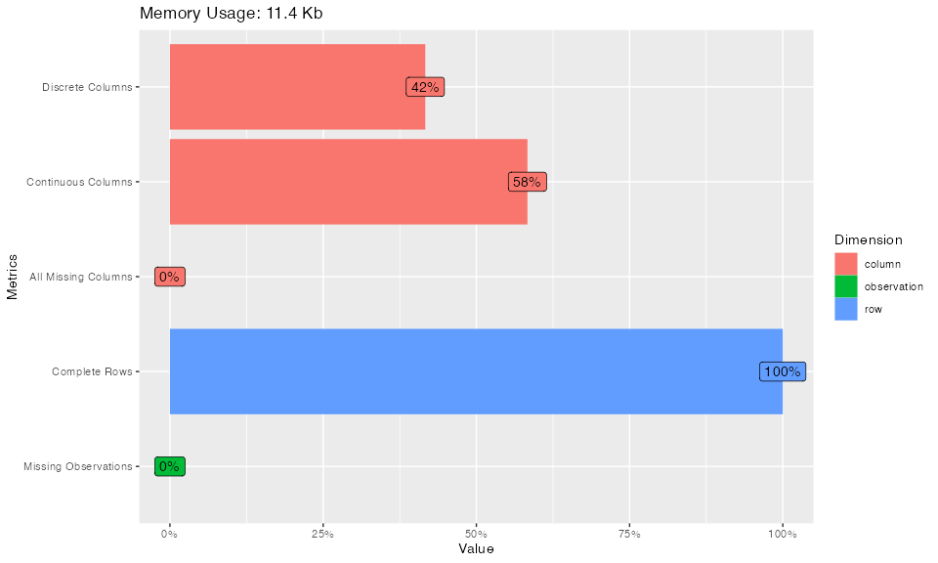

## 1.3 Qualitative variables

In this section, we examine the qualitative (categorical) variables in the dataset.

# General exploration of qualitative variables  
DataExplorer::plot_bar(datacomplete)

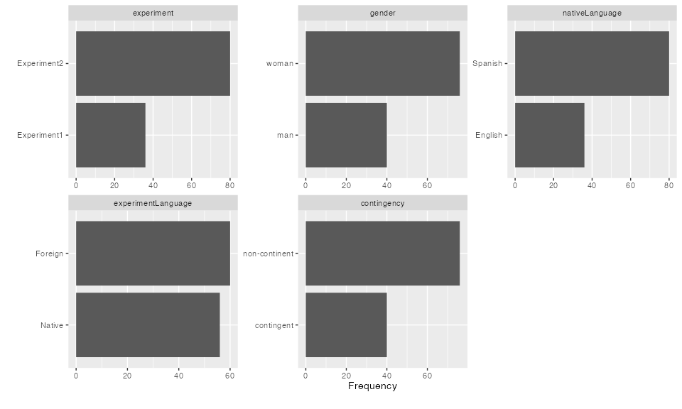

From the initial exploration, we observe that the first experiment has fewer participants compared to the second (36 vs. 80). The first experiment follows a factorial design with two groups based on experiment language (FL vs. NL). The second experiment includes four groups, based on experiment language and contingency (null vs. true). Additionally, more females (76) participated compared to males (40), with experiment 2 showing a more balanced sex distribution (3:1 ratio vs. ~1.5:1 ratio).

# Frequencies tables of Experiment and Gender  
table(datacomplete$experiment); table(datacomplete$gender)

Experiment1 Experiment2   
 36 80

man woman   
 40 76

table(datacomplete$experiment,datacomplete$gender)

man woman  
 Experiment1 9 27  
 Experiment2 31 49

# Ratio  
table(datacomplete$experiment,datacomplete$gender)[,2]/  
 table(datacomplete$experiment,datacomplete$gender)[,1]

Experiment1 Experiment2   
 3.000000 1.580645

# Bar plot   
library(ggplot2); library(ggokabeito)  
  
ggplot(datacomplete, aes(x = experiment, fill = gender)) +   
 geom_bar(position = position_dodge(preserve = "single")) +  
 scale_fill_okabe_ito() + # Color-blind friendly palette  
 labs(x = "Experiment", y = "Count") +   
 guides(fill = guide_legend(title = "Sex")) +  
 theme_bw()

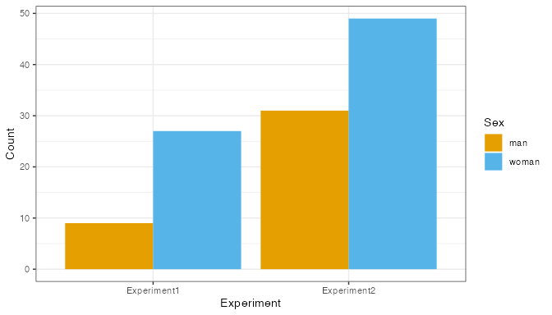

In the first experiment, participants were English students with Spanish as a FL, whereas in the second experiment, participants were Spanish students with English as a FL. This explains the difference in the first explorative bar plot concerning the differences in terms of NL (36 vs 80). In the first experiment, we have only the null contingency condition (N=36), whereas in the second experiment, we also have the true contingency condition (N=40 vs N=40), explaining the differences in the imbalance between the bars of the contingency variable.

# Frequencies tables of NL and Contingency x Experiment  
table(datacomplete$nativeLanguage)

English Spanish   
 36 80

table(datacomplete$contingency, datacomplete$experiment)

Experiment1 Experiment2  
 contingent 0 40  
 non-continent 36 40

## 1.4 Quantitative variables

In this section, we explore the distributions of the continuous variables across the two experiments. We visualize the aggregated histograms to observe the general distribution of these variables.

# Plotting histograms for all continuous variables  
DataExplorer::plot_histogram(datacomplete)

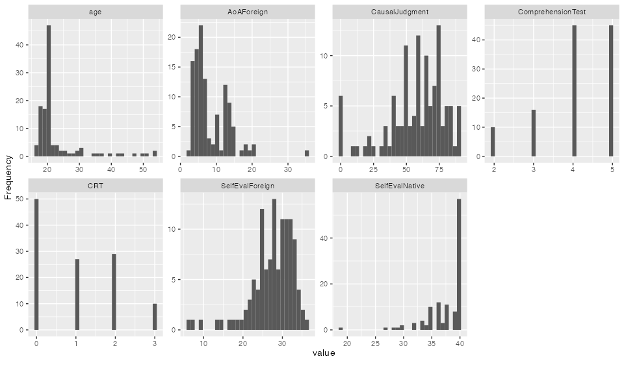

We also want to explore in greater detail the differences between the two experiments, as in the first experiment we have English students and in the second experiment, Spanish students.

# Plotting bivariate graphs for the continuous variables  
library(GGally)  
ggpairs(datacomplete[, c("age", "gender", "SelfEvalNative", "SelfEvalForeign",  
 "ComprehensionTest", "experiment")], columns= 1:5,  
 mapping = aes(fill=experiment))

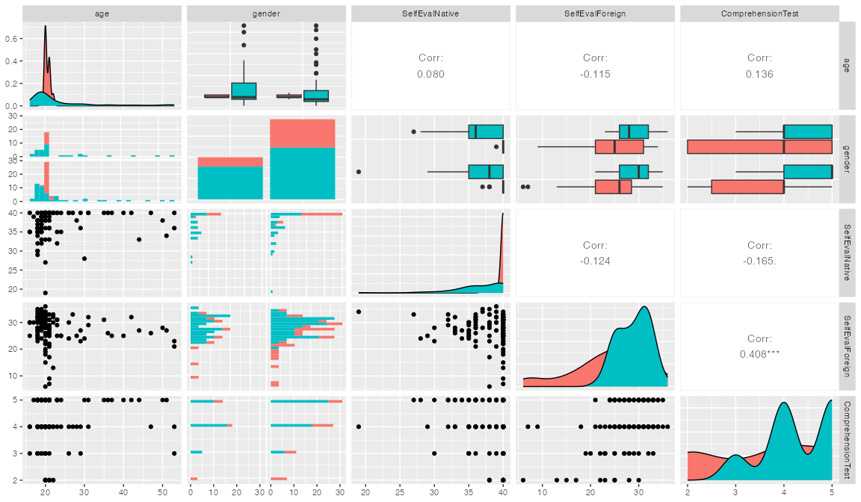

### 1.4.1 Age

In this section, we focus on the Age variable. The average age of participants is 22.78 years (M = 22.78, Mdn = 20, SD = 7.82, MAD = 1), which is typical of university students, though there are participants outside the typical range, with ages spanning from 16 to 53. Notably, 80% of the participants fall within the age range of 16 to 23.

library(pastecs); library(ggdist); library(ggthemes)  
  
# Descriptive statistics for Age  
summary(datacomplete$age)

Min. 1st Qu. Median Mean 3rd Qu. Max.   
 16.00 19.00 20.00 22.78 22.00 53.00

round(stat.desc(datacomplete$age, norm = TRUE), 2)

nbr.val nbr.null nbr.na min max range   
 116.00 0.00 0.00 16.00 53.00 37.00   
 sum median mean SE.mean CI.mean.0.95 var   
 2642.00 20.00 22.78 0.73 1.44 61.22   
 std.dev coef.var skewness skew.2SE kurtosis kurt.2SE   
 7.82 0.34 2.49 5.55 5.64 6.33   
 normtest.W normtest.p   
 0.62 0.00

# MAD and range  
median(abs(datacomplete$age - median(datacomplete$age))) # MAD calculation

[1] 1

mad(datacomplete$age) # MAD function

[1] 1.4826

quantile(datacomplete$age, probs = c(0, 0.80)) # Quantile for 80% range

0% 80%   
 16 23

# Distribution of Age   
ggplot(datacomplete, aes(y = age, fill = factor(1))) +   
 scale_fill_okabe_ito(order=3) +  
 stat_halfeye(adjust = 0.9, justification = -0.2,   
 .width = 0, point_colour = NA) +   
 geom_boxplot(width = 0.12, outlier.color = NA, alpha = 0.5) +   
 stat_dots(side = "left", justification = 1.1, binwidth = 0.25) +   
 labs(y = "Age", x = "") +   
 coord_flip() +   
 guides(fill = guide_legend(title = "")) +   
 theme_bw() +   
 theme(legend.position = "none")

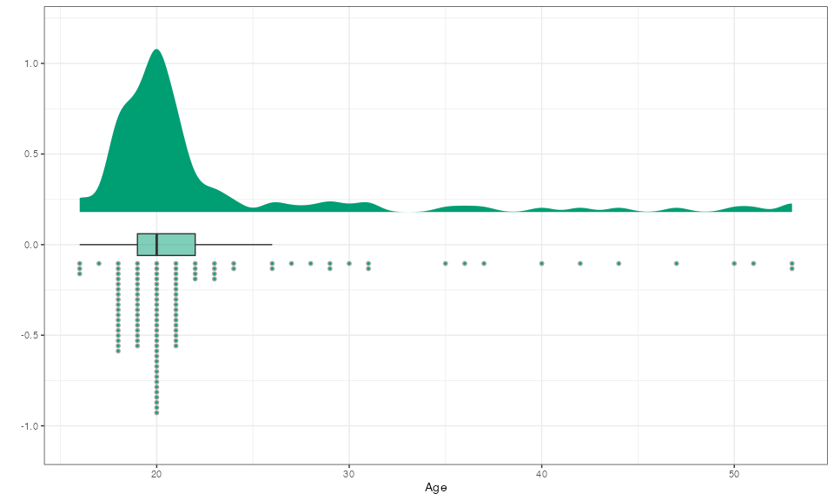

We observe that the age distributions differ between the two experiments. English students (M = 20.47, Mdn = 20, 1st Quartile = 20, 3rd Quartile = 21, range = 3, SD = 0.7) on Erasmus tend to be more homogeneous in age compared to the Spanish students (M = 23.81, Mdn = 20, 1st Quartile = 18, 3rd Quartile = 24.5, range = 37, SD = 9.24). The Spanish students show more variability, with a wider age range and more outliers.

# Age for each experiment  
aggregate(datacomplete$age, list(datacomplete$experiment), summary)

Group.1 x.Min. x.1st Qu. x.Median x.Mean x.3rd Qu. x.Max.  
1 Experiment1 19.00000 20.00000 20.00000 20.47222 21.00000 22.00000  
2 Experiment2 16.00000 18.00000 20.00000 23.81250 24.50000 53.00000

round(stat.desc(datacomplete$age[datacomplete$experiment == "Experiment1"], norm = TRUE), 2)

nbr.val nbr.null nbr.na min max range   
 36.00 0.00 0.00 19.00 22.00 3.00   
 sum median mean SE.mean CI.mean.0.95 var   
 737.00 20.00 20.47 0.12 0.24 0.48   
 std.dev coef.var skewness skew.2SE kurtosis kurt.2SE   
 0.70 0.03 0.59 0.75 -0.29 -0.19   
 normtest.W normtest.p   
 0.79 0.00

round(stat.desc(datacomplete$age[datacomplete$experiment == "Experiment2"], norm = TRUE), 2)

nbr.val nbr.null nbr.na min max range   
 80.00 0.00 0.00 16.00 53.00 37.00   
 sum median mean SE.mean CI.mean.0.95 var   
 1905.00 20.00 23.81 1.03 2.06 85.39   
 std.dev coef.var skewness skew.2SE kurtosis kurt.2SE   
 9.24 0.39 1.87 3.47 2.52 2.37   
 normtest.W normtest.p   
 0.70 0.00

# Age distributions  
ggplot(datacomplete, aes(y = age, x = experiment, fill = experiment)) +   
 stat_halfeye(adjust = 2, justification = -0.1,   
 .width = 0.1, point_colour = NA) +   
 geom_boxplot(width = 0.12, outlier.color = NA, alpha = 0.5) +   
 stat_dots(side = "left", justification = 1.1, binwidth = 0.25) +   
 labs(x = "Experiment", y = "Age") +   
 theme_bw() + theme(legend.position = "none") +  
 scale_fill_okabe_ito(order=c(4,5))

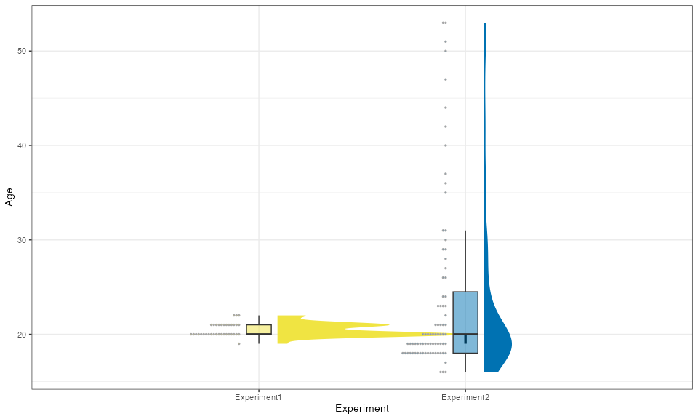

### 1.4.2 Age of FL acquisition

The Age of FL Acquisition (AoA) has an average of 8.45 years (M = 8.45, Mdn = 7, SD = 5.07, MAD = 3). The majority of participants started learning a foreign language during primary or secondary school, with the first quartile at age 5 and the third quartile at age 12. However, there are a few outliers (min = 2, max = 35). Over 99% of participants began studying a foreign language before turning 20.

# AoA descriptive statistics  
summary(datacomplete$AoAForeign)

Min. 1st Qu. Median Mean 3rd Qu. Max.   
 2.000 5.000 7.000 8.448 12.000 35.000

round(stat.desc(datacomplete$AoAForeign, norm = TRUE), 2)

nbr.val nbr.null nbr.na min max range   
 116.00 0.00 0.00 2.00 35.00 33.00   
 sum median mean SE.mean CI.mean.0.95 var   
 980.00 7.00 8.45 0.47 0.93 25.75   
 std.dev coef.var skewness skew.2SE kurtosis kurt.2SE   
 5.07 0.60 1.65 3.68 4.91 5.51   
 normtest.W normtest.p   
 0.85 0.00

# MAD and proportion of participants with AoA > 20  
median(abs(datacomplete$AoAForeign - median(datacomplete$AoAForeign)))

[1] 3

mad(datacomplete$AoAForeign)

[1] 4.4478

sum(datacomplete$AoAForeign > 20) / length(datacomplete$AoAForeign)

[1] 0.00862069

# AoA distribution  
ggplot(datacomplete, aes(y = AoAForeign, fill = factor(1))) +   
 scale_fill_okabe_ito(order=8) +   
 stat_halfeye(adjust = 0.9, justification = -0.2,   
 .width = 0, point_colour = NA) +   
 geom_boxplot(width = 0.12, outlier.color = NA, alpha = 0.5) +   
 stat_dots(side = "left", justification = 1.1, binwidth = 0.25) +   
 labs(x = "", y = "Age of Foreign Language Acquisition (AoA)") +   
 coord_flip() +   
 guides(fill = guide_legend(title = "")) +   
 theme_bw() +   
 theme(legend.position = "none")

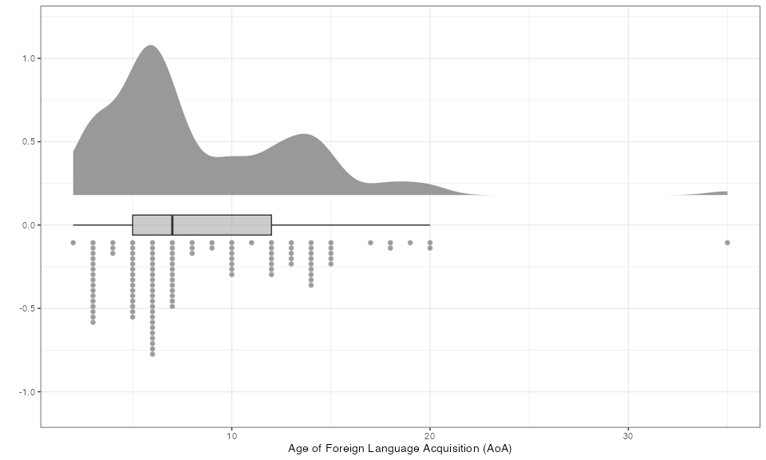

An important consideration is whether there are differences in the AoA between the two groups of students. English-speaking students (M = 12.61, Mdn = 13.5, SD = 4.08, min = 4, max = 20) began learning Spanish at a later age compared to Spanish-speaking students (M = 6.57, Mdn = 6, SD = 4.32, min = 2, max = 35).

The Cohen’s d, as standardized measure of effect size, is 1.43, suggesting a large effect. Additionally, the Cliff’s delta, a non-parametric measure of effect size that is more robust to small sample sizes, non-normality, and heteroscedasticity, is 0.74, confirming the large effect.

# AoA descriptive statistics   
aggregate(datacomplete$AoAForeign, list(datacomplete$experiment), summary)

Group.1 x.Min. x.1st Qu. x.Median x.Mean x.3rd Qu. x.Max.  
1 Experiment1 4.00000 10.75000 13.50000 12.61111 15.00000 20.00000  
2 Experiment2 2.00000 5.00000 6.00000 6.57500 7.00000 35.00000

round(stat.desc(datacomplete$AoAForeign[datacomplete$experiment == "Experiment1"], norm = TRUE), 2)

nbr.val nbr.null nbr.na min max range   
 36.00 0.00 0.00 4.00 20.00 16.00   
 sum median mean SE.mean CI.mean.0.95 var   
 454.00 13.50 12.61 0.68 1.38 16.64   
 std.dev coef.var skewness skew.2SE kurtosis kurt.2SE   
 4.08 0.32 -0.39 -0.50 -0.36 -0.23   
 normtest.W normtest.p   
 0.94 0.04

round(stat.desc(datacomplete$AoAForeign[datacomplete$experiment == "Experiment2"], norm = TRUE), 2)

nbr.val nbr.null nbr.na min max range   
 80.00 0.00 0.00 2.00 35.00 33.00   
 sum median mean SE.mean CI.mean.0.95 var   
 526.00 6.00 6.58 0.48 0.96 18.65   
 std.dev coef.var skewness skew.2SE kurtosis kurt.2SE   
 4.32 0.66 3.87 7.19 21.47 20.19   
 normtest.W normtest.p   
 0.65 0.00

# AoA distributions  
ggplot(datacomplete, aes(y = AoAForeign, x = experiment, fill = experiment)) +   
 stat_halfeye(adjust = 0.9, justification = -0.2,   
 .width = 0, point_colour = NA) +   
 geom_boxplot(width = 0.12, outlier.color = NA, alpha = 0.5) +   
 stat_dots(side = "left", justification = 1.1, binwidth = 0.25) +   
 scale_fill_okabe_ito(order = c(7, 8)) +   
 labs(x = "Experiment", y = "Age of Foreign Language Acquisition (AoA)") +  
 theme_bw() +   
 theme(legend.position = "none")

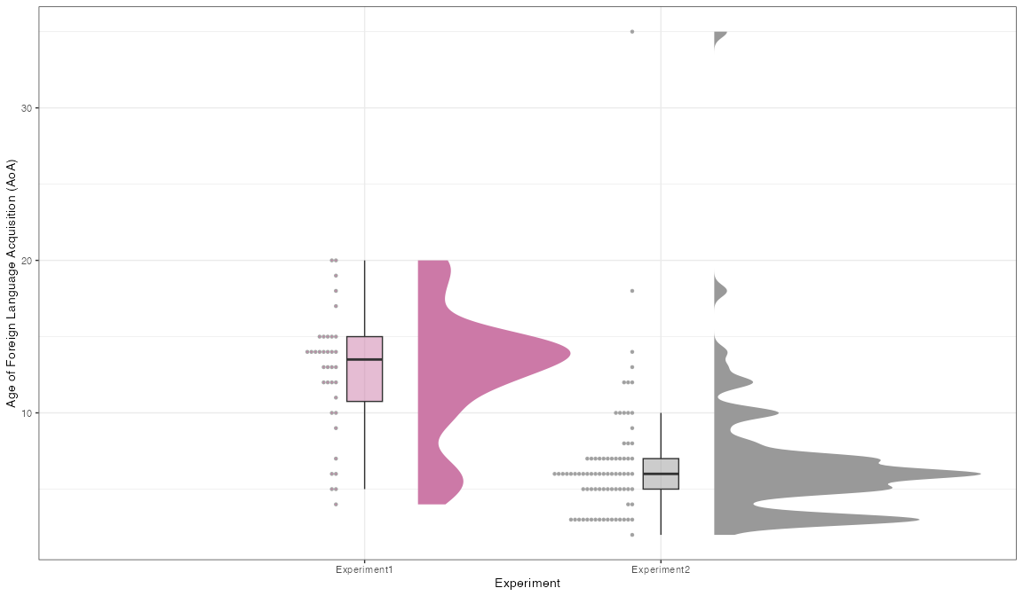

# Overlap   
library(overlapping)  
  
overlap_stats <- list(  
 x1 = datacomplete$AoAForeign[datacomplete$experiment == "Experiment1"],  
 x2 = datacomplete$AoAForeign[datacomplete$experiment == "Experiment2"]  
)  
  
overlap_result <- overlapping::overlap(overlap_stats, type = "2")  
overlap_result

$OV  
[1] 0.200368

# Cohen's d  
library(effectsize)  
  
cohens_d_result <- cohens_d(  
 x = datacomplete$AoAForeign[datacomplete$experiment == "Experiment1"],  
 y = datacomplete$AoAForeign[datacomplete$experiment == "Experiment2"]  
)  
cohens_d_result

Cohen's d | 95% CI  
------------------------  
1.42 | [0.98, 1.85]  
  
- Estimated using pooled SD.

# Cliff's delta   
cliffs_delta_result <- cliffs_delta(  
 x = datacomplete$AoAForeign[datacomplete$experiment == "Experiment1"],  
 y = datacomplete$AoAForeign[datacomplete$experiment == "Experiment2"]  
)  
cliffs_delta_result

r (rank biserial) | 95% CI  
--------------------------------  
0.74 | [0.61, 0.82]

### 1.4.3 Age - Age of foreign language acquisition

The difference between age and AoA provides insight into how many years participants have been practicing a foreign language. On average, participants have been speaking a foreign language for over 10 years, although there is considerable variability in the data (M = 14.33, Mdn = 14, SD = 7.8, 1st quartile = 10, 3rd quartile = 16).

# Calculating the difference  
datacomplete$y <- datacomplete$age - datacomplete$AoAForeign  
  
# Summary statistics of the difference  
summary(datacomplete$y)

Min. 1st Qu. Median Mean 3rd Qu. Max.   
 0.00 10.00 14.00 14.33 16.00 43.00

round(stat.desc(datacomplete$y, norm=T),2)

nbr.val nbr.null nbr.na min max range   
 116.00 1.00 0.00 0.00 43.00 43.00   
 sum median mean SE.mean CI.mean.0.95 var   
 1662.00 14.00 14.33 0.73 1.44 61.65   
 std.dev coef.var skewness skew.2SE kurtosis kurt.2SE   
 7.85 0.55 1.50 3.34 3.40 3.82   
 normtest.W normtest.p   
 0.86 0.00

# Distribution of the difference   
ggplot(datacomplete, aes(y = y, fill=factor(1))) +   
 scale_fill_okabe_ito(order=5) +  
 stat_halfeye(adjust = 0.9, justification = -0.2, .width = 0, point_colour = NA) +  
 geom_boxplot(width = 0.12, outlier.color = NA, alpha = 0.5) +  
 stat_dots(side = "left", justification = 1.1, binwidth = 0.25) +  
 labs(x = "", y = "Age - AoA (years)") +   
 coord_flip() +  
 guides(fill = guide_legend(title = "")) +  
 theme_bw() +  
 theme(legend.position = "none")

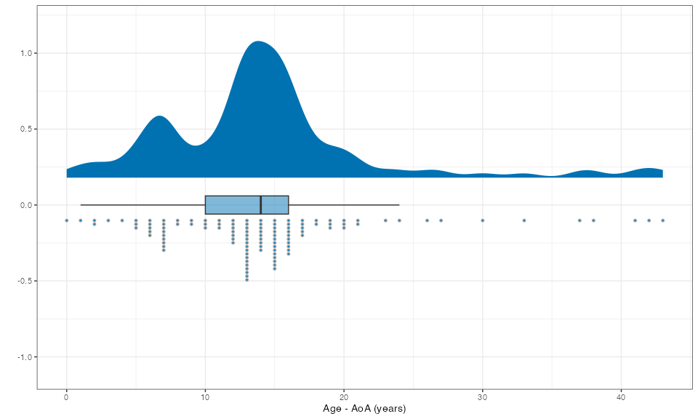

# Summary statistics of the difference by group  
aggregate(datacomplete$y, list(datacomplete$experiment), summary)

Group.1 x.Min. x.1st Qu. x.Median x.Mean x.3rd Qu. x.Max.  
1 Experiment1 0.000000 6.000000 7.000000 7.861111 10.000000 16.000000  
2 Experiment2 4.000000 13.000000 15.000000 17.237500 18.000000 43.000000

round(stat.desc(datacomplete$y[datacomplete$experiment == "Experiment1"], norm = TRUE), 2)

nbr.val nbr.null nbr.na min max range   
 36.00 1.00 0.00 0.00 16.00 16.00   
 sum median mean SE.mean CI.mean.0.95 var   
 283.00 7.00 7.86 0.69 1.39 16.98   
 std.dev coef.var skewness skew.2SE kurtosis kurt.2SE   
 4.12 0.52 0.37 0.47 -0.47 -0.30   
 normtest.W normtest.p   
 0.94 0.05

round(stat.desc(datacomplete$y[datacomplete$experiment == "Experiment2"], norm = TRUE), 2)

nbr.val nbr.null nbr.na min max range   
 80.00 0.00 0.00 4.00 43.00 39.00   
 sum median mean SE.mean CI.mean.0.95 var   
 1379.00 15.00 17.24 0.83 1.64 54.59   
 std.dev coef.var skewness skew.2SE kurtosis kurt.2SE   
 7.39 0.43 2.01 3.74 3.83 3.61   
 normtest.W normtest.p   
 0.73 0.00

# Distribution of the difference by group  
ggplot(datacomplete, aes(y = y, x = experiment, fill = experiment)) +   
 stat_halfeye(adjust = 0.9, justification = -0.2,   
 .width = 0, point_colour = NA) +   
 geom_boxplot(width = 0.12, outlier.color = NA, alpha = 0.5) +   
 stat_dots(side = "left", justification = 1.1, binwidth = 0.25) +   
 scale_fill_okabe_ito(order = c(1, 2)) +   
 labs(x = "Experiment", y = "Age - AoA (years)") +  
 theme_bw() +   
 theme(legend.position = "none")

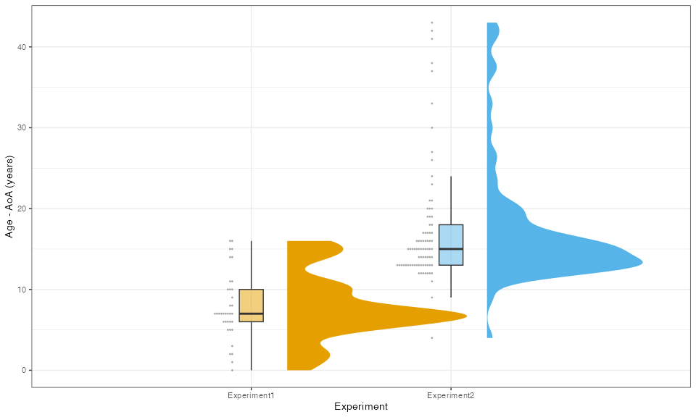

### 1.4.4 Comprehension test

The results of the comprehension test indicate that most participants were able to complete the test successfully. The median score was 4 (1st Quartile = 4, 3rd Quartile = 5). A few participants obtained slightly lower scores, with the minimum score being 2, but no participant scored 1 or 0. The comprehension test was designed to assess whether participants could understand information presented in a FL, providing a measure of their FL comprehension abilities.

# Comprehension test description  
summary(datacomplete$ComprehensionTest)

Min. 1st Qu. Median Mean 3rd Qu. Max.   
 2.000 4.000 4.000 4.078 5.000 5.000

round(stat.desc(datacomplete$ComprehensionTest, norm=T),2)

nbr.val nbr.null nbr.na min max range   
 116.00 0.00 0.00 2.00 5.00 3.00   
 sum median mean SE.mean CI.mean.0.95 var   
 473.00 4.00 4.08 0.09 0.17 0.87   
 std.dev coef.var skewness skew.2SE kurtosis kurt.2SE   
 0.93 0.23 -0.79 -1.75 -0.27 -0.31   
 normtest.W normtest.p   
 0.82 0.00

# Distribution of comprehension test scores  
ggplot(datacomplete, aes(x = ComprehensionTest, fill=factor(1))) +   
 geom_histogram(alpha = 0.5)+  
 geom_boxplot(width=6, alpha=.5, position = position_nudge(y=-5))+  
 scale_fill_okabe_ito(order=1)+  
 labs(x="Number of correct answers", y="Frequencies")+   
 theme_bw()+theme(legend.position="none")

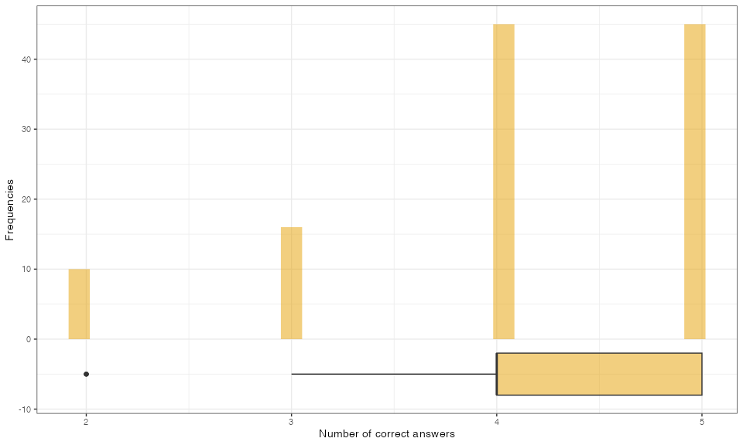

We now examine whether there are any differences between the two experimental groups in their comprehension test scores. English-speaking students performed slightly worse (M = 3.58, Mdn = 4) compared to Spanish-speaking students, who had a higher mean score (M = 4.30, Mdn = 4).

# Comparison of comprehension test scores between the two experiments  
aggregate(datacomplete$ComprehensionTest, list(datacomplete$experiment), summary)

Group.1 x.Min. x.1st Qu. x.Median x.Mean x.3rd Qu. x.Max.  
1 Experiment1 2.000000 2.000000 4.000000 3.583333 5.000000 5.000000  
2 Experiment2 3.000000 4.000000 4.000000 4.300000 5.000000 5.000000

# Distributions of comprehension test scores by experiment group  
ggplot(datacomplete, aes(x = ComprehensionTest, fill=experiment)) +   
 geom_bar(alpha = 0.5, position=position_dodge2())+  
 labs(x="Number of correct answers", y="Frequencies")+   
 scale_fill_okabe_ito(order=c(5,7))+  
 theme_bw()

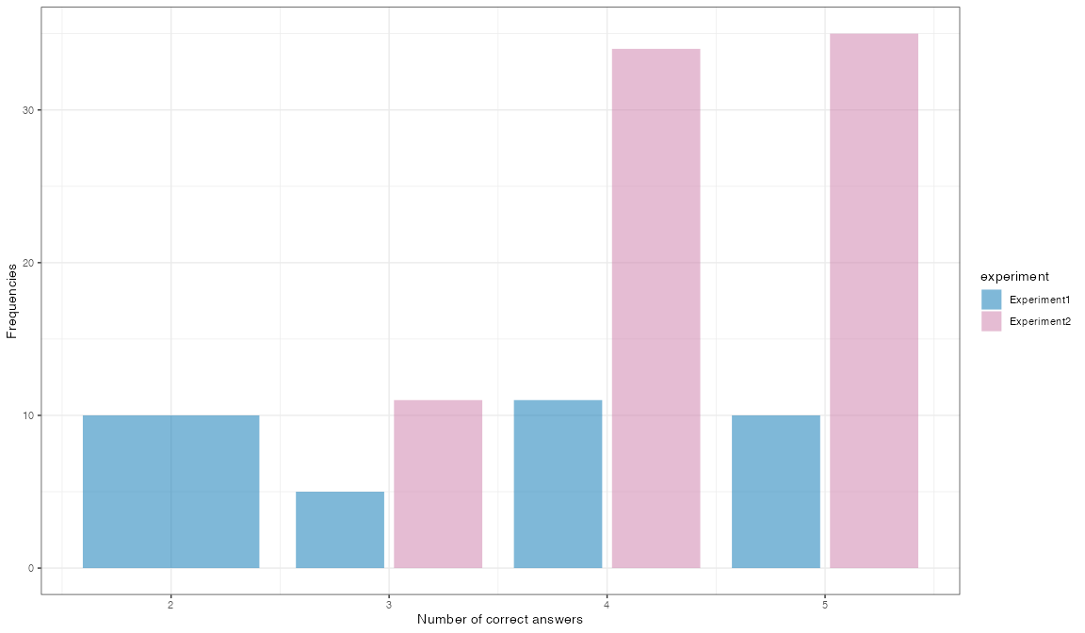

### 1.4.4 Self-assessment of language fluency

The self-assessment scores of FL fluency (M = 27.48, Mdn = 28, SD = 5.44) are generally lower than those for NL fluency (M = 37.6, Mdn = 39, SD = 3.48). The Cohen’s d value of 2.21 suggests a very large effect, indicating a substantial difference between the self-assessments of native and foreign language fluency. Moreover, the Cliff’s Delta value of -0.92 suggests minimal overlap between the two distributions, further reinforcing the strong distinction between the self-reported fluency in the two languages.

# Self-assessment of NL fluency  
summary(datacomplete$SelfEvalNative)

Min. 1st Qu. Median Mean 3rd Qu. Max.   
 19.0 36.0 39.0 37.6 40.0 40.0

round(stat.desc(datacomplete$SelfEvalNative, norm=T),2)

nbr.val nbr.null nbr.na min max range   
 116.00 0.00 0.00 19.00 40.00 21.00   
 sum median mean SE.mean CI.mean.0.95 var   
 4362.00 39.00 37.60 0.32 0.64 12.08   
 std.dev coef.var skewness skew.2SE kurtosis kurt.2SE   
 3.48 0.09 -2.15 -4.78 6.48 7.27   
 normtest.W normtest.p   
 0.72 0.00

# Self-assessment of FL fluency  
summary(datacomplete$SelfEvalForeign)

Min. 1st Qu. Median Mean 3rd Qu. Max.   
 6.00 25.00 28.00 27.48 31.00 36.00

round(stat.desc(datacomplete$SelfEvalForeign, norm=T),2)

nbr.val nbr.null nbr.na min max range   
 116.00 0.00 0.00 6.00 36.00 30.00   
 sum median mean SE.mean CI.mean.0.95 var   
 3188.00 28.00 27.48 0.51 1.00 29.61   
 std.dev coef.var skewness skew.2SE kurtosis kurt.2SE   
 5.44 0.20 -1.55 -3.45 3.35 3.76   
 normtest.W normtest.p   
 0.88 0.00

# Visualizing the self-assessment of NL fluency  
a <- ggplot(datacomplete, aes(y = SelfEvalNative, fill=factor(1))) +   
 scale_fill_manual(values=c("yellow3")) +  
 stat_halfeye(adjust = 0.9, justification = -0.2, .width = 0, point_colour = NA) +  
 geom_boxplot(width = 0.12, outlier.color = NA, alpha = 0.5) +  
 stat_dots(side = "left", justification = 1.1, binwidth = 0.25) +  
 labs(x="Native Language", y="Self-Evaluation") +   
 guides(fill=guide_legend(title="")) +  
 ylim(0,40) +  
 theme_bw() +  
 theme(legend.position="none")  
  
# Visualizing the self-assessment of FL fluency  
b <- ggplot(datacomplete, aes(y = SelfEvalForeign, fill=factor(1))) +   
 scale_fill_manual(values=c("pink4")) +  
 stat_halfeye(adjust = 0.9, justification = -0.2, .width = 0, point_colour = NA) +  
 geom_boxplot(width = 0.12, outlier.color = NA, alpha = 0.5) +  
 stat_dots(side = "left", justification = 1.1, binwidth = 0.25) +  
 labs(x="Foreign Language", y="Self-Evaluation") +   
 guides(fill=guide_legend(title="")) +  
 ylim(0,40) +  
 theme_bw() +  
 theme(legend.position="none")  
  
# Displaying both plots together  
library(gridExtra)  
grid.arrange(a, b, nrow = 1)

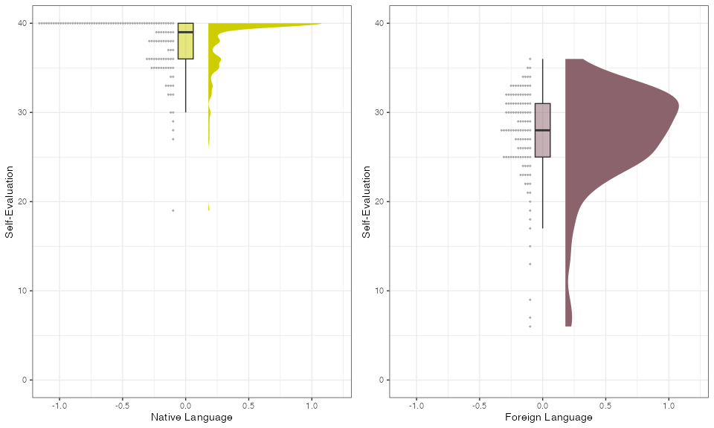

# Cohen's d and Cliff's delta   
cohens_d(datacomplete$SelfEvalNative, datacomplete$SelfEvalForeign)

Cohen's d | 95% CI  
------------------------  
2.22 | [1.89, 2.54]  
  
- Estimated using pooled SD.

cliffs_delta(datacomplete$SelfEvalNative, datacomplete$SelfEvalForeign)

r (rank biserial) | 95% CI  
--------------------------------  
0.92 | [0.90, 0.94]

When examining the self-assessment of NL fluency, English-speaking students rated their fluency higher (M = 39.72, Mdn = 40, SD = 0.74, min = 37, max = 40) compared to their Spanish-speaking counterparts (M = 36.65, Mdn = 38, SD = 3.79, min = 19, max = 40). It is notable that the Spanish group exhibited a greater variability in their self-assessments.

The standardized effect size is 0.97, which indicates a large effect, suggesting a meaningful difference in the self-assessed NL fluency between the two groups.

# Self-assessment of NL fluency in the two experiments  
 aggregate(datacomplete$SelfEvalNative, list(datacomplete$experiment), summary)

Group.1 x.Min. x.1st Qu. x.Median x.Mean x.3rd Qu. x.Max.  
1 Experiment1 37.00000 40.00000 40.00000 39.72222 40.00000 40.00000  
2 Experiment2 19.00000 35.00000 38.00000 36.65000 40.00000 40.00000

round(stat.desc(datacomplete$SelfEvalNative[datacomplete$experiment=="Experiment1"], norm=T),2)

nbr.val nbr.null nbr.na min max range   
 36.00 0.00 0.00 37.00 40.00 3.00   
 sum median mean SE.mean CI.mean.0.95 var   
 1430.00 40.00 39.72 0.12 0.25 0.55   
 std.dev coef.var skewness skew.2SE kurtosis kurt.2SE   
 0.74 0.02 -2.40 -3.06 4.53 2.95   
 normtest.W normtest.p   
 0.43 0.00

round(stat.desc(datacomplete$SelfEvalNative[datacomplete$experiment=="Experiment2"], norm=T),2)

nbr.val nbr.null nbr.na min max range   
 80.00 0.00 0.00 19.00 40.00 21.00   
 sum median mean SE.mean CI.mean.0.95 var   
 2932.00 38.00 36.65 0.42 0.84 14.38   
 std.dev coef.var skewness skew.2SE kurtosis kurt.2SE   
 3.79 0.10 -1.74 -3.23 4.52 4.25   
 normtest.W normtest.p   
 0.81 0.00

# Visualizing the self-assessment of NL fluency  
 ggplot(datacomplete, aes(y = SelfEvalNative, x= experiment, fill = experiment)) +   
 geom_boxplot(width = 0.12, outlier.color = NA, alpha = 0.5) +  
 stat_dots(side = "left", justification = 1.1, binwidth = 0.25) +  
 scale_fill_okabe_ito() +  
 labs(x = "Experiment", y = "Self-Evaluation NL") +   
 theme_bw() +  
 theme(legend.position = "none")

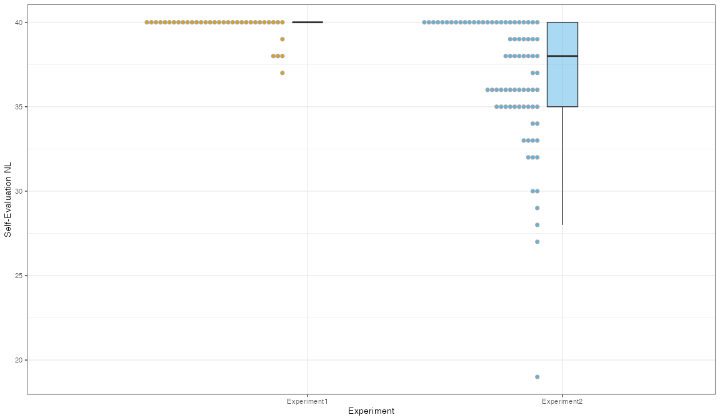

# Cohen's d  
 cohens_d(x = datacomplete$SelfEvalNative[datacomplete$experiment == "Experiment1"],  
 y = datacomplete$SelfEvalNative[datacomplete$experiment == "Experiment2"])

Cohen's d | 95% CI  
------------------------  
0.97 | [0.55, 1.38]  
  
- Estimated using pooled SD.

# Cliff's Delta   
 cliffs_delta(datacomplete$SelfEvalNative[datacomplete$experiment == "Experiment1"],  
 datacomplete$SelfEvalNative[datacomplete$experiment == "Experiment2"])

r (rank biserial) | 95% CI  
--------------------------------  
0.59 | [0.43, 0.72]

Regarding the self-assessment of FL fluency, English-speaking students rated their proficiency lower (M = 24.19, Mdn = 25.5, SD = 7.45, min = 6, max = 35) compared to their Spanish-speaking counterparts (M = 28.96, Mdn = 29.5, SD = 3.37, min = 21, max = 36), although the English group displayed greater variability in their ratings.

The standardized effect size is 0.96, which indicates a large effect, suggesting that the difference in self-assessed FL fluency between the two groups is meaningful.

# Self-assessment of FL fluency in the two experiments  
aggregate(datacomplete$SelfEvalForeign, list(datacomplete$experiment), summary)

Group.1 x.Min. x.1st Qu. x.Median x.Mean x.3rd Qu. x.Max.  
1 Experiment1 6.00000 20.75000 25.50000 24.19444 29.25000 35.00000  
2 Experiment2 21.00000 26.00000 29.50000 28.96250 32.00000 36.00000

round(stat.desc(datacomplete$SelfEvalForeign[datacomplete$experiment=="Experiment1"], norm=T),2)

nbr.val nbr.null nbr.na min max range   
 36.00 0.00 0.00 6.00 35.00 29.00   
 sum median mean SE.mean CI.mean.0.95 var   
 871.00 25.50 24.19 1.24 2.52 55.48   
 std.dev coef.var skewness skew.2SE kurtosis kurt.2SE   
 7.45 0.31 -0.82 -1.04 -0.06 -0.04   
 normtest.W normtest.p   
 0.93 0.02

round(stat.desc(datacomplete$SelfEvalForeign[datacomplete$experiment=="Experiment2"], norm=T),2)

nbr.val nbr.null nbr.na min max range   
 80.00 0.00 0.00 21.00 36.00 15.00   
 sum median mean SE.mean CI.mean.0.95 var   
 2317.00 29.50 28.96 0.38 0.75 11.38   
 std.dev coef.var skewness skew.2SE kurtosis kurt.2SE   
 3.37 0.12 -0.19 -0.36 -0.92 -0.87   
 normtest.W normtest.p   
 0.97 0.04

# Visualizing the self-assessment of FL fluency  
ggplot(datacomplete, aes(y = SelfEvalForeign, x= experiment, fill = experiment)) +   
 stat_halfeye(adjust = 0.9, justification = -0.2,  
 .width = 0, point_colour = NA) +  
 geom_boxplot(width = 0.12, outlier.color = NA, alpha = 0.5) +  
 stat_dots(side = "left", justification = 1.1, binwidth = 0.25) +  
 labs(x = "Experiment", y = "Self-Evaluation FL") +   
 theme_bw() +  
 theme(legend.position = "none")

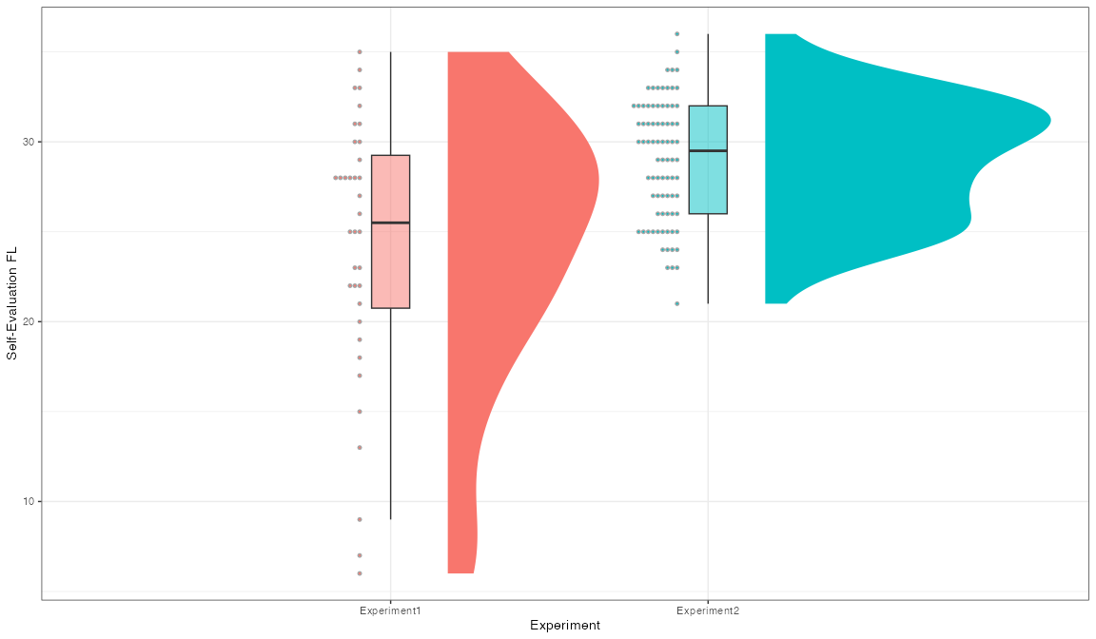

# Cohen's d  
cohens_d(x = datacomplete$SelfEvalForeign[datacomplete$experiment == "Experiment1"],  
 y = datacomplete$SelfEvalForeign[datacomplete$experiment == "Experiment2"])

Cohen's d | 95% CI  
--------------------------  
-0.96 | [-1.37, -0.54]  
  
- Estimated using pooled SD.

# Cliff's Delta   
cliffs_delta(datacomplete$SelfEvalForeign[datacomplete$experiment == "Experiment1"],  
 datacomplete$SelfEvalForeign[datacomplete$experiment == "Experiment2"])

r (rank biserial) | 95% CI  
----------------------------------  
-0.39 | [-0.57, -0.19]

### 1.4.5 Other bivariate relationships

We briefly observe the correlation matrix between continuous variables. Among other correlations worth noting, there is a moderate positive correlation (r = 0.41) between self-assessed foreign language fluency and the comprehension test. Consistent with expectations, those who acquired their foreign language at a younger age also rated their proficiency higher in the foreign language (r = -0.53).

DataExplorer::plot_correlation(datacomplete[,c(2,7,8,9,10,11,12)])

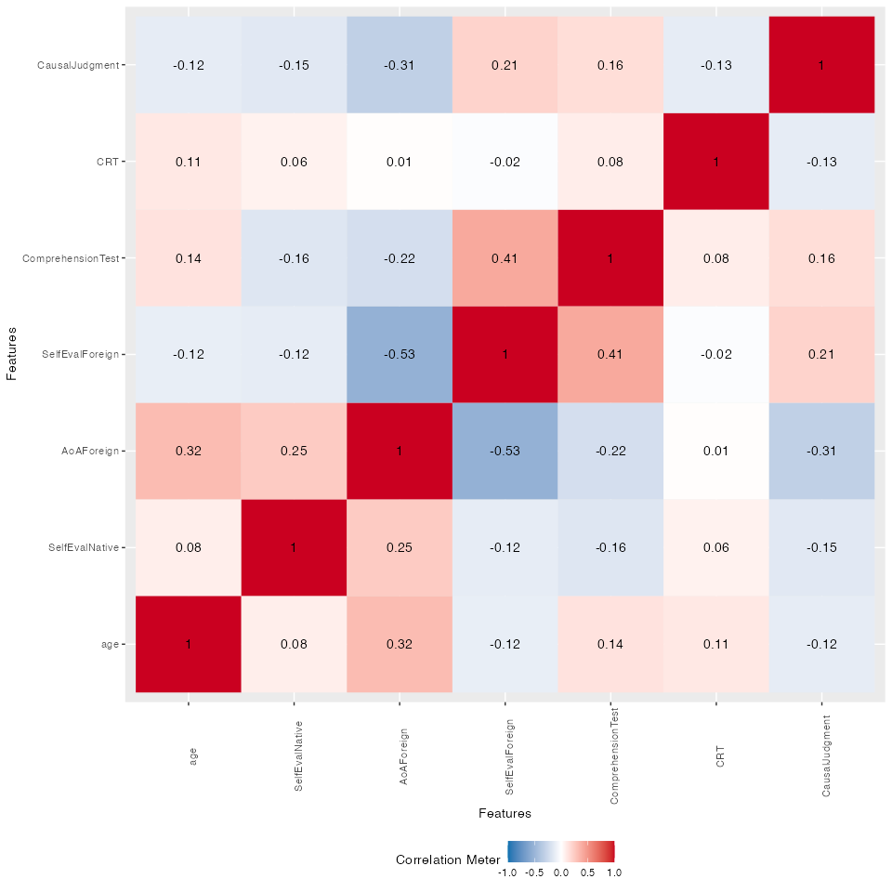

# 2. First experiment main results

## 2.1 Descriptive statistics

The first experiment included 36 participants, and the only condition tested was the null contingency condition.

# Extract data for the first experiment  
data1 <- datacomplete[datacomplete$experiment == "Experiment1", ]  
nrow(data1) # Confirming the number of participants

[1] 36

We now describe the subjective ratings of causality provided by participants, which were measured on a 101-point Likert scale. The scores ranged from 1 to 83, with the median (Mdn = 53.5) being fairly close to the mean (M = 51.31) and indicating a somewhat symmetrical distribution. The standard deviation (SD = 20.63) reflects moderate variability in participants’ responses. The first and third quartiles (Q1 = 39.25, Q3 = 65.5) are relatively symmetric, suggesting a distribution that does not have extreme skewness.

The results of the Shapiro-Wilk normality test (W = 0.96, p = 0.25) indicate that the distribution does not significantly deviate from normality, meaning we do not reject the null hypothesis of normality.

# Summary statistics  
data1$CausalJudgment

[1] 50 44 32 57 60 75 65 73 70 44 57 41 25 40 35 12 35 50 53 10 1 60 54 37 65  
[26] 70 65 80 51 83 75 55 82 52 22 67

summary(data1$CausalJudgment)

Min. 1st Qu. Median Mean 3rd Qu. Max.   
 1.00 39.25 53.50 51.31 65.50 83.00

round(stat.desc(data1$CausalJudgment, norm = T), 2)

nbr.val nbr.null nbr.na min max range   
 36.00 0.00 0.00 1.00 83.00 82.00   
 sum median mean SE.mean CI.mean.0.95 var   
 1847.00 53.50 51.31 3.44 6.98 425.65   
 std.dev coef.var skewness skew.2SE kurtosis kurt.2SE   
 20.63 0.40 -0.56 -0.71 -0.37 -0.24   
 normtest.W normtest.p   
 0.96 0.25

# Distribution of Causal Judgment  
ggplot(data1, aes(y = CausalJudgment, fill = factor(1))) +   
 scale_fill_okabe_ito(order = 5) +  
 stat_halfeye(adjust = 0.9, justification = -0.2, .width = 0, point_colour = NA) +  
 geom_boxplot(width = 0.12, outlier.color = NA, alpha = 0.5) +  
 stat_dots(side = "left", justification = 1.1, binwidth = 1, size=2) +  
 labs(x = "", y = "Causal Judgment (0-100)") +   
 coord_flip() +  
 guides(fill = guide_legend(title = "")) +  
 theme_bw() +  
 theme(legend.position = "none")

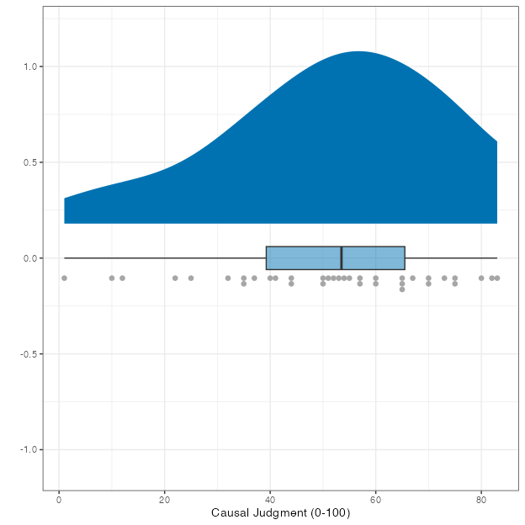

The goal now is to compare the causality scores between the two groups that completed the task in either their native or foreign language. There are 20 participants in the foreign language group and 16 participants in the native language group. NL is English, and FL is Spanish.

# Number of participants in each group   
length(data1$CausalJudgment[data1$experimentLanguage == "Foreign"])

[1] 20

length(data1$CausalJudgment[data1$experimentLanguage == "Native"])

[1] 16

The range of causality scores is wider in the FL condition (from 1 to 75) compared to the NL condition (from 22 to 83). This suggests that participants in the FL condition have a broader spread of judgments.

In the NL condition, the distribution of causality scores has a mean of 64.5 with a standard deviation of 15.12. The median score of 66 is very close to the mean, indicating a symmetrical distribution.

In contrast, in the FL condition, the mean causality score is 42.5 with a standard deviation of 18.43, indicating more variability in this group. The median score of 42 is very close to the mean, suggesting a fairly symmetric distribution. The first and third quartiles are 34 and 53.

# Descriptive statistics  
aggregate(x=data1$CausalJudgment, by=list(data1$experimentLanguage), FUN=summary)

Group.1 x.Min. x.1st Qu. x.Median x.Mean x.3rd Qu. x.Max.  
1 Foreign 1.00 34.25 42.50 40.75 53.25 75.00  
2 Native 22.00 56.50 66.00 64.50 73.50 83.00

round(stat.desc(data1$CausalJudgment[data1$experimentLanguage=="Foreign"], norm=T),2)

nbr.val nbr.null nbr.na min max range   
 20.00 0.00 0.00 1.00 75.00 74.00   
 sum median mean SE.mean CI.mean.0.95 var   
 815.00 42.50 40.75 4.12 8.63 339.67   
 std.dev coef.var skewness skew.2SE kurtosis kurt.2SE   
 18.43 0.45 -0.45 -0.44 -0.43 -0.22   
 normtest.W normtest.p   
 0.96 0.60

round(stat.desc(data1$CausalJudgment[data1$experimentLanguage=="Native"], norm=T),2)

nbr.val nbr.null nbr.na min max range   
 16.00 0.00 0.00 22.00 83.00 61.00   
 sum median mean SE.mean CI.mean.0.95 var   
 1032.00 66.00 64.50 3.78 8.06 228.67   
 std.dev coef.var skewness skew.2SE kurtosis kurt.2SE   
 15.12 0.23 -1.17 -1.04 1.33 0.61   
 normtest.W normtest.p   
 0.89 0.05

# Visualization  
ggplot(data1, aes(y = CausalJudgment, x = experimentLanguage, fill = experimentLanguage)) +   
 stat_halfeye(adjust = 0.9, justification = -0.2, .width = 0, point_colour = NA) +   
 geom_boxplot(width = 0.12, outlier.color = NA, alpha = 0.5) +   
 stat_dots(side = "left", justification = 1.1, binwidth = 1, size=2) +   
 scale_fill_okabe_ito(order = c(4, 5)) +   
 labs(x = "Experiment", y = "Causal Judgment") +  
 theme_bw() +   
 theme(legend.position = "none")

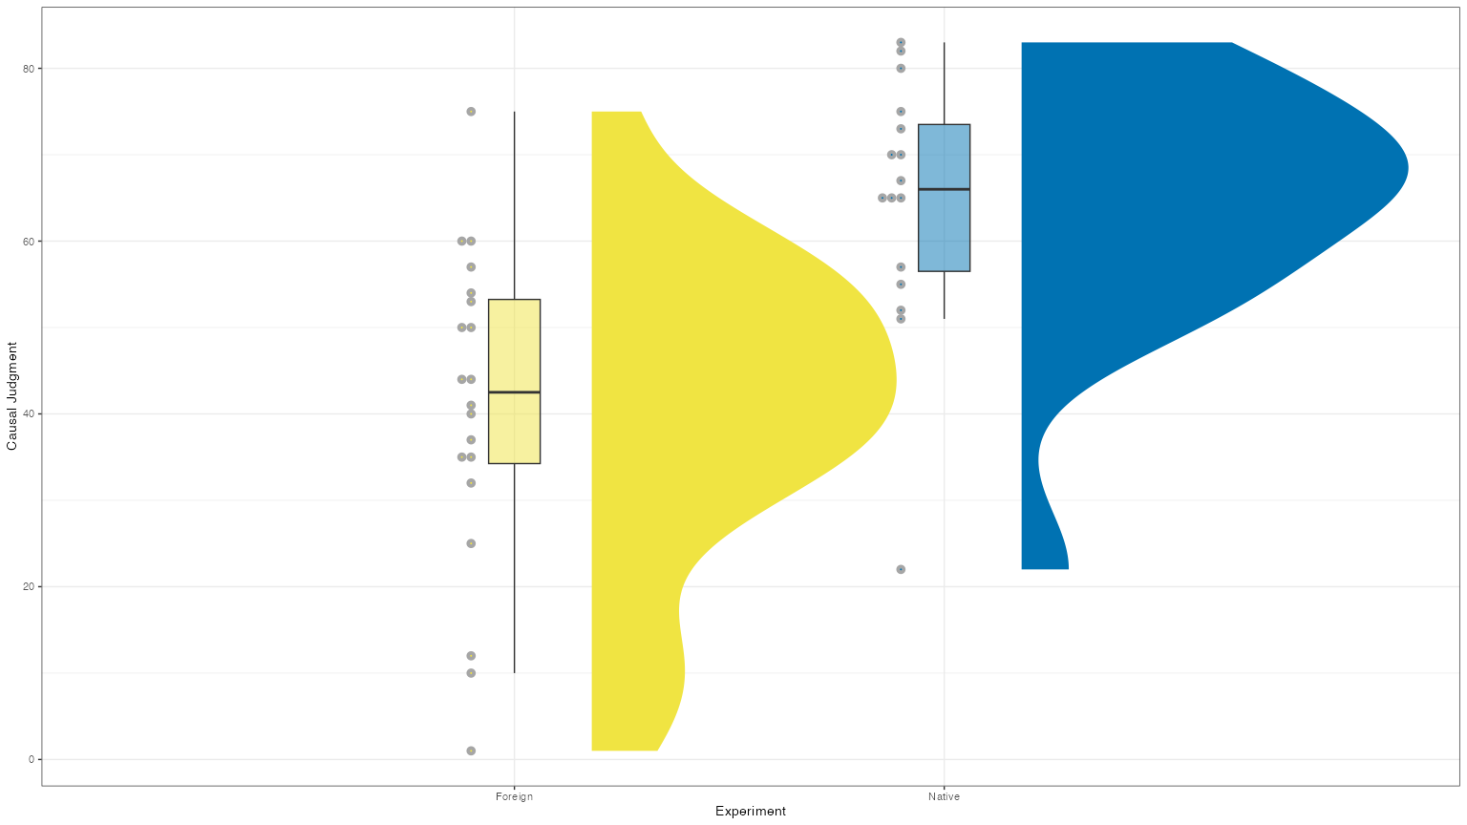

## 2.2 Effect size

The Cohen’s d effect size is 1.39, which is very large.

# Cohen's d   
cohens_d(x = data1$CausalJudgment[data1$experimentLanguage == "Foreign"],   
 y = data1$CausalJudgment[data1$experimentLanguage == "Native"])

Cohen's d | 95% CI  
--------------------------  
-1.39 | [-2.12, -0.65]  
  
- Estimated using pooled SD.

# Cliff's Delta   
cliffs_delta(x = data1$CausalJudgment[data1$experimentLanguage == "Foreign"],   
 y = data1$CausalJudgment[data1$experimentLanguage == "Native"])

r (rank biserial) | 95% CI  
----------------------------------  
-0.73 | [-0.86, -0.49]

We examine the BF. In this case, the data are 114 times more likely under the alternative hypothesis (H1) than under the null hypothesis (H0), suggesting strong evidence in favor of the effect.

# BF  
ttestBF(x = data1$CausalJudgment[data1$experimentLanguage == "Foreign"],   
 y = data1$CausalJudgment[data1$experimentLanguage == "Native"])

Bayes factor analysis  
--------------  
[1] Alt., r=0.707 : 114.429 ±0%  
  
Against denominator:  
 Null, mu1-mu2 = 0   
---  
Bayes factor type: BFindepSample, JZS

# 3. Second experiment main results

## 3.1 Descriptive statistics

The second experiment involved 80 participants. To analyze the data, we focus on the null contingency condition, which includes 40 data points.

# Extract data for the second experiment  
data2 <- datacomplete[datacomplete$experiment == "Experiment2", ]  
nrow(data2)

[1] 80

data2 <- data2[data2$contingency == "non-continent", ]

The subjective ratings of causality in the null contingency condition show a wide range of scores from 0 to 90. The mean is 53.65, with a median of 60, and the standard deviation is 25.06. The first and third quartiles are somewhat asymmetric (1st Quartile = 46.75, 3rd Quartile = 69.50). The distribution has a negative skew of -0.95 and a kurtosis value of 0.09. The Shapiro-Wilk test for normality (W = 0.88, p < 0.05) indicates that the distribution deviates from normality.

# Summary statistics  
data2$CausalJudgment

[1] 78 60 85 60 65 40 80 67 90 0 60 47 50 79 60 58 50 80 86 65 49 62 0 50 65  
[26] 41 46 51 0 65 61 48 71 0 0 40 21 72 69 75

summary(data2$CausalJudgment)

Min. 1st Qu. Median Mean 3rd Qu. Max.   
 0.00 46.75 60.00 53.65 69.50 90.00

round(stat.desc(data2$CausalJudgment, norm = T), 2)

nbr.val nbr.null nbr.na min max range   
 40.00 5.00 0.00 0.00 90.00 90.00   
 sum median mean SE.mean CI.mean.0.95 var   
 2146.00 60.00 53.65 3.96 8.02 628.08   
 std.dev coef.var skewness skew.2SE kurtosis kurt.2SE   
 25.06 0.47 -0.95 -1.28 0.09 0.06   
 normtest.W normtest.p   
 0.88 0.00

# Distribution of Causal Judgment  
ggplot(data2, aes(y = CausalJudgment, fill = factor(1))) +   
 scale_fill_okabe_ito(order = 5) +  
 stat_halfeye(adjust = 0.9, justification = -0.2, .width = 0, point_colour = NA) +  
 geom_boxplot(width = 0.12, outlier.color = NA, alpha = 0.5) +  
 stat_dots(side = "left", justification = 1.1, binwidth = 1, size=2) +  
 labs(x = "", y = "Causal Judgment (0-100)") +   
 coord_flip() +  
 guides(fill = guide_legend(title = "")) +  
 theme_bw() +  
 theme(legend.position = "none")

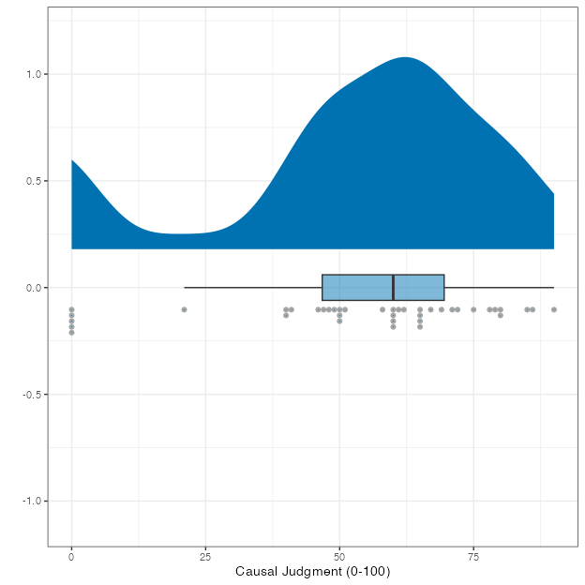

Now, let’s focus on comparing Causal judgment scores between the two groups that completed the task in a null contingency condition. There are 20 participants in each group (NL = Spanish, FL = English).

# Number of participants in each group   
length(data2$CausalJudgment[data2$experimentLanguage == "Foreign"])

[1] 20

length(data2$CausalJudgment[data2$experimentLanguage == "Native"])

[1] 20

In the NL condition, the distribution has a mean of 63 (M = 63, SD = 20.49), and the median of 62.5 is close to the mean. The first and third quartiles are somewhat asymmetric (56 and 63). The distribution has a negative skew of -1.23 and is leptokurtic (1.96).

In the FL condition, the distribution has a mean of 44 (M = 44.30, SD = 26.18), with a median of 49.5, which is not close to the mean. The first and third quartiles are symmetric around the median (35 and 65), indicating a fairly symmetric distribution. The distribution shows a slight negative skew of -0.69 and is platykurtic (kurtosis=-1.02).

# Descriptive statistics  
aggregate(x = data2$CausalJudgment, by = list(data2$experimentLanguage), FUN = summary)

Group.1 x.Min. x.1st Qu. x.Median x.Mean x.3rd Qu. x.Max.  
1 Foreign 0.00 35.25 49.50 44.30 65.00 75.00  
2 Native 0.00 56.00 62.50 63.00 79.25 90.00

round(stat.desc(data2$CausalJudgment[data2$experimentLanguage == "Foreign"], norm = T), 2)

nbr.val nbr.null nbr.na min max range   
 20.00 4.00 0.00 0.00 75.00 75.00   
 sum median mean SE.mean CI.mean.0.95 var   
 886.00 49.50 44.30 5.85 12.25 685.27   
 std.dev coef.var skewness skew.2SE kurtosis kurt.2SE   
 26.18 0.59 -0.69 -0.67 -1.02 -0.51   
 normtest.W normtest.p   
 0.85 0.01

round(stat.desc(data2$CausalJudgment[data2$experimentLanguage == "Native"], norm = T), 2)

nbr.val nbr.null nbr.na min max range   
 20.00 1.00 0.00 0.00 90.00 90.00   
 sum median mean SE.mean CI.mean.0.95 var   
 1260.00 62.50 63.00 4.58 9.59 419.89   
 std.dev coef.var skewness skew.2SE kurtosis kurt.2SE   
 20.49 0.33 -1.23 -1.20 1.96 0.99   
 normtest.W normtest.p   
 0.88 0.02

# Visualization  
ggplot(data2, aes(y = CausalJudgment, x = experimentLanguage, fill = experimentLanguage)) +   
 stat_halfeye(adjust = 0.9, justification = -0.2, .width = 0, point_colour = NA) +   
 geom_boxplot(width = 0.12, outlier.color = NA, alpha = 0.5) +   
 stat_dots(side = "left", justification = 1.1, binwidth = 1, size=2) +   
 scale_fill_okabe_ito(order = c(4, 5)) +   
 labs(x = "Experiment", y = "Causal Judgment") +  
 theme_bw() +   
 theme(legend.position = "none")

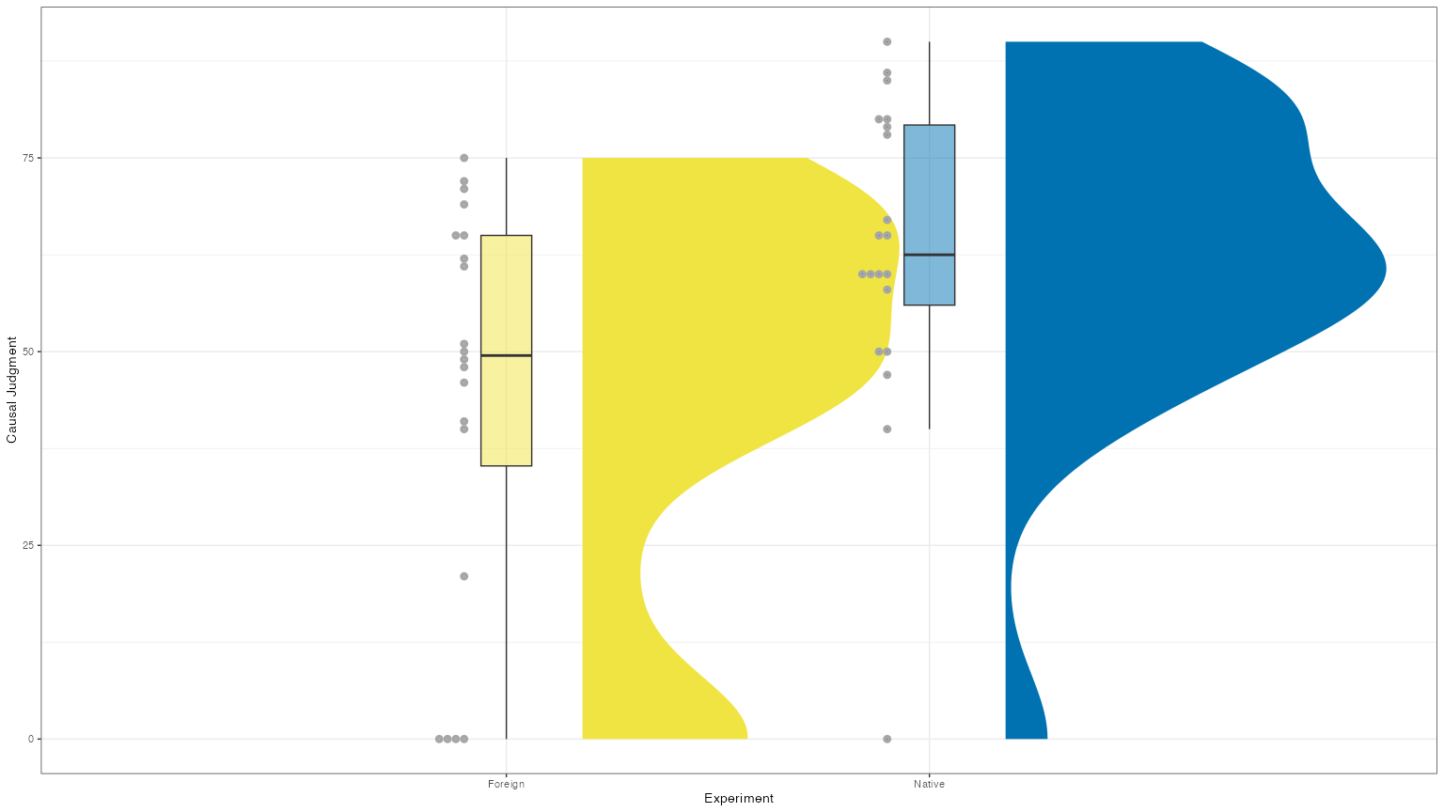

## 3.2 Effect size

The standardized effect size is 0.8, which is considered a large effect size.

library(effectsize)  
cohens_d(x = data2$CausalJudgment[data2$experimentLanguage == "Foreign"],   
 y = data2$CausalJudgment[data2$experimentLanguage == "Native"])

Cohen's d | 95% CI  
--------------------------  
-0.80 | [-1.44, -0.15]  
  
- Estimated using pooled SD.

# Cliff's Delta   
cliffs_delta(x = data2$CausalJudgment[data2$experimentLanguage == "Foreign"],   
 y = data2$CausalJudgment[data2$experimentLanguage == "Native"])

r (rank biserial) | 95% CI  
----------------------------------  
-0.41 | [-0.66, -0.08]

Next, we examine the Bayes Factor. The data are 3 times more likely under the alternative hypothesis (H1) than under the null hypothesis (H0), providing moderate evidence for the alternative hypothesis.

# BF  
ttestBF(x = data2$CausalJudgment[data2$experimentLanguage == "Foreign"],   
 y = data2$CausalJudgment[data2$experimentLanguage == "Native"])

Bayes factor analysis  
--------------  
[1] Alt., r=0.707 : 3.433997 ±0.01%  
  
Against denominator:  
 Null, mu1-mu2 = 0   
---  
Bayes factor type: BFindepSample, JZS

Arnold, J. (2024). *Ggthemes: Extra themes, scales and geoms for ’ggplot2’*. <https://CRAN.R-project.org/package=ggthemes>

Auguie, B. (2017). *gridExtra: Miscellaneous functions for "grid" graphics*. <https://CRAN.R-project.org/package=gridExtra>

Barrett, M. (2024). *Ggokabeito: ’Okabe-ito’ scales for ’ggplot2’ and ’ggraph’*. <https://github.com/malcolmbarrett/ggokabeito>

Ben-Shachar, M., Lüdecke, D., & Makowski, D. (2020). Effectsize: Estimation of effect size indices and standardized parameters. *Journal of Open Source Software*, *5*(56), 2815. <https://doi.org/10.21105/joss.02815>

Cui, B. (2024). *DataExplorer: Automate data exploration and treatment*. <https://CRAN.R-project.org/package=DataExplorer>

Díaz-Lago, M., & Matute, H. (2019). Thinking in a foreign language reduces the causality bias. *Quarterly Journal of Experimental Psychology*, *72*(1), 41–51. <https://doi.org/10.1177/1747021818755326>

Fox, J., & Weisberg, S. (2019). *An r companion to applied regression, third edition*. Sage. <https://www.john-fox.ca/Companion/>

Grosjean, P., & Ibanez, F. (2024). *Pastecs: Package for analysis of space-time ecological series*. <https://CRAN.R-project.org/package=pastecs>

Kay, M. (2024). Ggdist: Visualizations of distributions and uncertainty in the grammar of graphics. *IEEE Transactions on Visualization and Computer Graphics*, *30*(1), 414–424. <https://doi.org/10.1109/TVCG.2023.3327195>

Masked Citation. (n.d.). *Masked Title*.

Morey, R., & Rouder, J. (2024). *BayesFactor: Computation of bayes factors for common designs*. <https://CRAN.R-project.org/package=BayesFactor>

Pastore, M., Di Loro, P. A., Mingione, M., & Calcagni’, A. (2022). *Overlapping: Estimation of overlapping in empirical distributions*. <https://CRAN.R-project.org/package=overlapping>

Schloerke, B., Cook, D., Larmarange, J., Briatte, F., Marbach, M., Thoen, E., Elberg, A., & Crowley, J. (2024). *GGally: Extension to ’ggplot2’*. <https://CRAN.R-project.org/package=GGally>

Wickham, H. (2016). *ggplot2: Elegant graphics for data analysis*. Springer-Verlag.